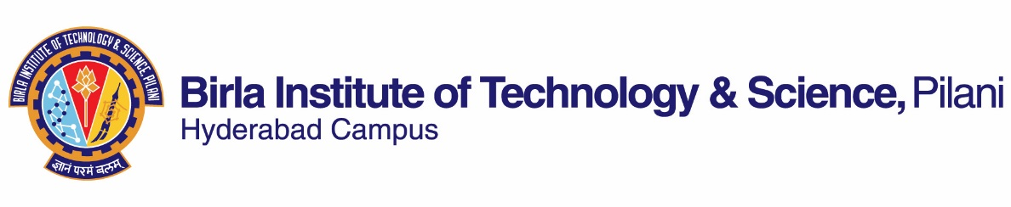

**FIRST SEMESTER 2019-2020**

# Course Handout Part II

01-08-2019

In addition to part-I (General Handout for all courses appended to the time table) this portion gives further specific details regarding the course.

*Course No.* :  *CHEM F326*

## Course Title : Solid State Chemistry

## Instructor-in-Charge : Dr. Sounak Roy

**Scope and Objective of the Course:** This course emphasis the concepts in solid state chemistry through the comprehensive survey of different synthetic techniques, their characterization, and their properties. Focus will be given on the structure-property relationship of materials. Introduction to nanomaterials with recent advances in material science and technology is also provided.

**Textbooks:**

1. ‘Solid State Chemistry and its Applications’, Anthony R. West, Wiley-India Edition 2007.

**Reference books**

1. ‘Nanomaterials Chemistry – Recent Developments and New Directions’, Edited by C.N.R.Rao, A. Mueller, A.K.Cheetham, Wiley-Vch Edition 2007.

2. Materials Science and Engineering-an Introduction by William d.callister, jr. Seventh Edition, John Wiley (2007)

3. Material Science and Engineering by V. Raghavan, Fifth Edition, Prentice-Hall of India private Limited (2004)

**Course Plan:**

|  |  |  |  |
| --- | --- | --- | --- |
| **Lecture No.** | **Learning objectives** | **Topics to be covered** | **Chapter in the Text Book** |
| 1 | What is Solid State Chemistry? | Introduction to solid state chemistry | TB Ch 1 |
| 2-5 | Understanding a wide range of materials synthetic strategy | Preparative Methods | TB Ch 2 |
| 6-8 | Learning various characterization techniques like Thermal Analysis, XRD, XPS, TEM, SEM | Characterization of Inorganic Solids | TB Ch 3, 4 & 5 |
| 9-11 | Crystal Structures – Descriptive Crystal Chemistry, Factors influencing the crystal structures | TB Ch 7 & 8 |
| 12-13 | Crystal Defects and Non-Stoichiometry | Crystal Defects and Non-Stoichiometry | TB Ch 9 |
| 14-16 | 1D, 2D, 3D defects, Evaluating the importance of defects | Solid Solutions | TB Ch 10 |
| 17-18 | Magnetic, electronic, electrical and optical properties of solid materials arising out of structural properties and their application | Ionic Conductivity and Solid Electrolytes | TB Ch 13 |
| 20-22 | Electronic properties and band Theory: Metals, Semiconductors, Inorganic Solids, Color | TB Ch 14 |
| 23-36 | Electrical Properties | TB Ch 15 |
| 27-31 | Magnetic Properties | TB Ch 16 |
| 32-34 | Optical Properties: Luminescence, Lasers | TB Ch 17 |
| 36-42 | Synthesis, properties and new developments of nanomaterials | Nanomaterials Chemistry | RB-A Ch 1-5 |

**Evaluation Scheme:**

|  |  |  |  |  |
| --- | --- | --- | --- | --- |
| **Component** | **Duration** | **Weightage (%)** | **Date & Time** | **Nature of Component** |
| Assignment + Presentation | - | 20% | Continuous | Open book |
| Mid Semester Test | 90 min | 35% | 4/10, 3.30 -- 5.00 PM | Closed book |
| Comprehensive Examination | 180 min | 45% | 12/12 AN | Closed book |

**Chamber Consultation Hour:** Will be announced in class and notified in Notice board.

**Notices:** Will be announced in class and notified in Notice board.

**Make-up Policy:** Make up would be considered only for **genuine reasons**.

**Academic Honesty and Integrity Policy**: Academic honesty and integrity are to be maintained by all the students throughout the semester and no type of academic dishonesty is acceptable.

**INSTRUCTOR-IN-CHARGE**